

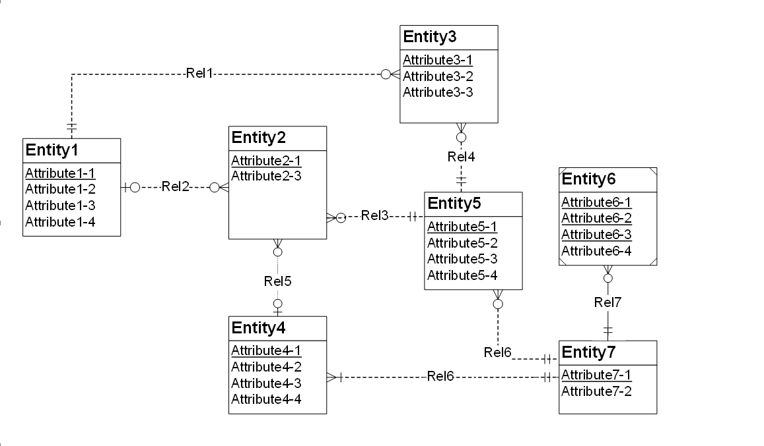

Errors in diagram are:

Rel-2 🡺 Redundant Foreign Key Violation

Attribute 1-1, Attribute4-1 should not be present

Rel-3 🡺 Attribute Name rule violation

Two Attribute have cannot have same name as Attribute2-1 is 2 times appearing so rename attribute is you want to include I have omitted rename is to show the difference.

Rel-7 🡺 Identity dependency rule violation

As entity 6 is week entity type it must be dependent on some other entity thus entity 7 in our case but it must have 1-m relationship with solid line which is not there.

Rel-6 🡺 identifying relationship rule violations

Weak entity or child entity should use solid line in relationship since entity 7 is strong entity or parent that so it must be represent by dotted line.